Manual for InstagramCheck

Click this character “+” to create a task, then just name it:
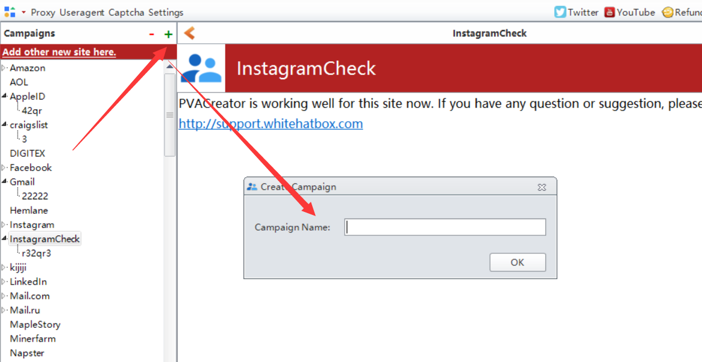

Following are the necessary variables needed to enter data before run：
1, Table Information:
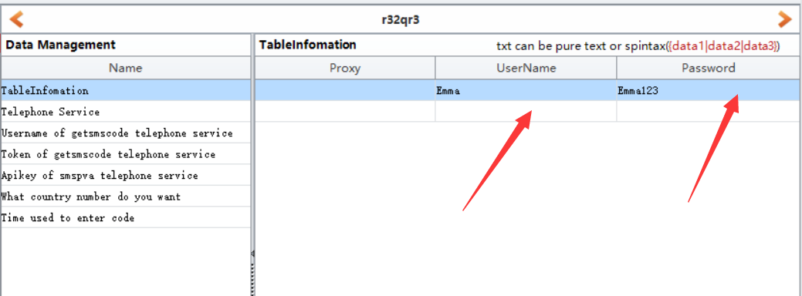
Proxy: proxy format is: ip:port ip:port:username:password
Eg: 127.152.349.159:8080 or 127.152.349.159:8080:emma:emma22r3
UserName: the username of your Instagram
Password: the password of your Instagram

2, Telephone Service:
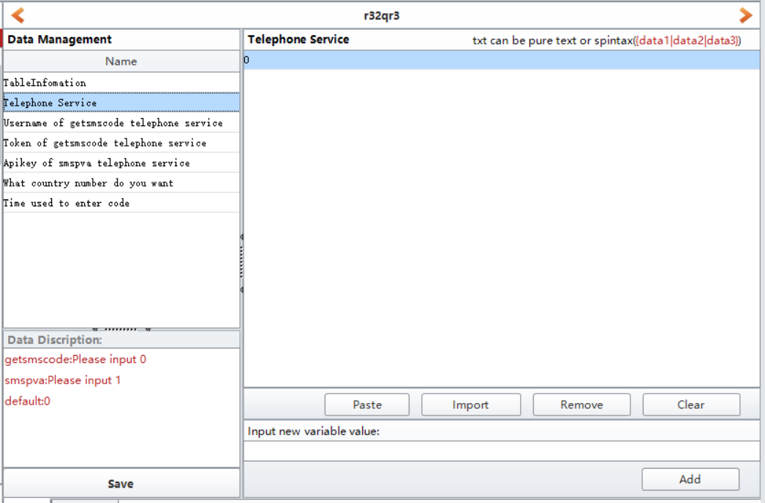
This is the 3rd party phone service we are using in this software, it is used to auto take and verify phone number if Instagram asks for during login in.
- If you enter 1, then please register an account in smspva, then charge for your account, then you can find your account apikey in your account profile panel. Then enter it to “Apikey of smspva telephone service” field.
http://smspva.com/
- If you enter 0, then please register an account in getsmscode, then charge for your account, then you can find your account username and token in your account profile panel. Then enter them to “Username of getsmscode telephone service”and ”Token of getsmscode telephone service” fields.
http://getsmscode.com/

3, What country number do you want
Choose which country phone number you want to use to verify your account.
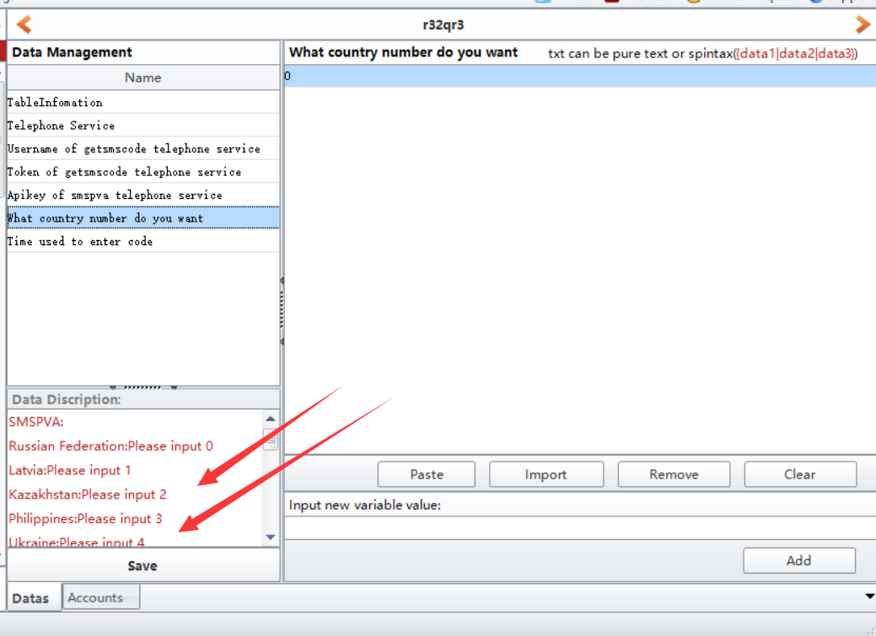

- Save
click Save button to save all data you entered. Then in Account from, you can view all data.
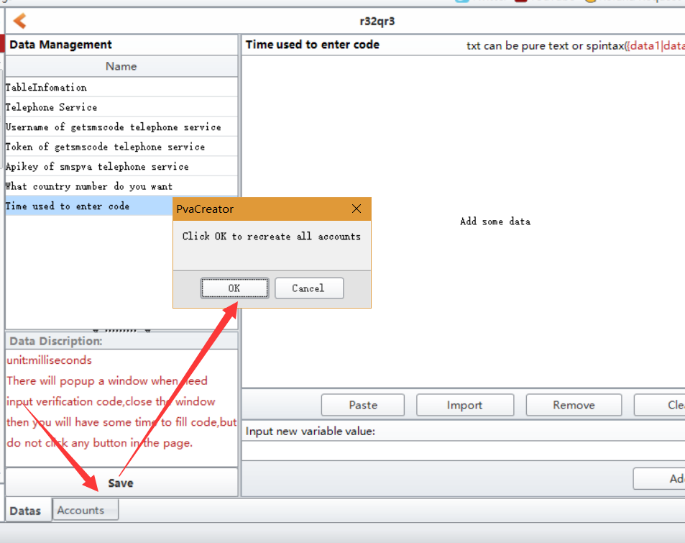
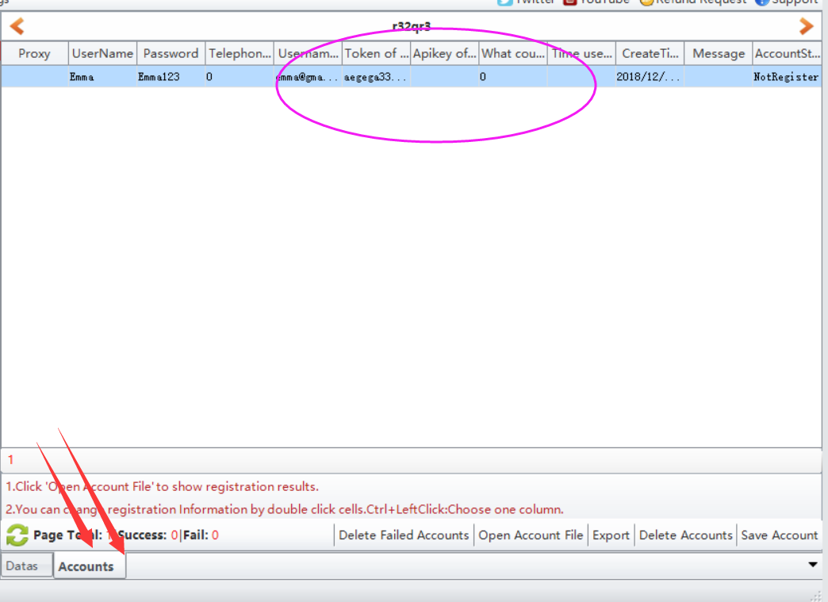

5, click Start button to start to run. When it starts to run, here will be a debug window open, and you can view the whole running process.
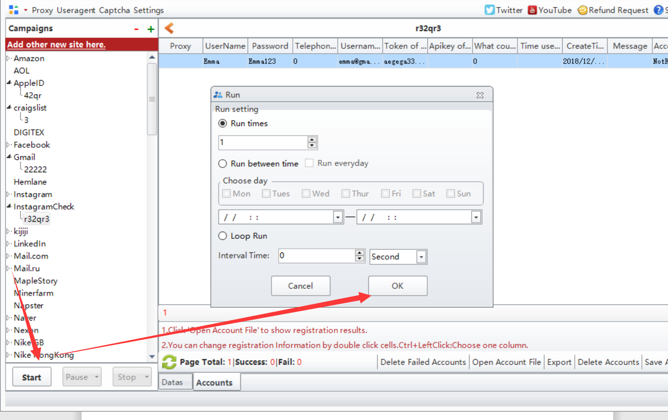

Options under “Bind Data”:
Import from file: import the data from your local prepared file at a time. Note: please choose the column first where you need to upload the data to.
UseRandom: custom some letters, numbers to auto generate data for these information. Such as full name, age, password. Note: please choose the column first where you need to custom and auto generate data.
Eg: if the first character is Funny, i will auto generate 1-4 number behind it. The first picture is the settings, the second one is the result it generates.
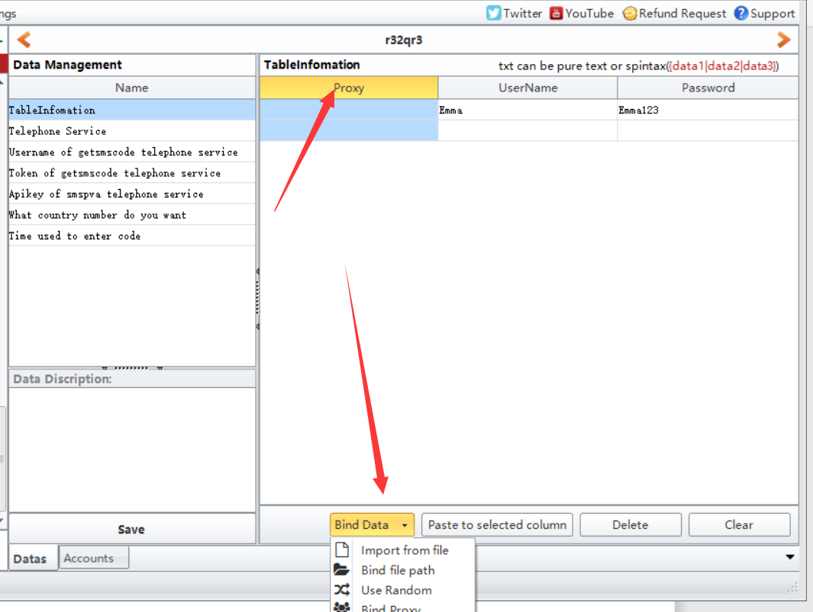
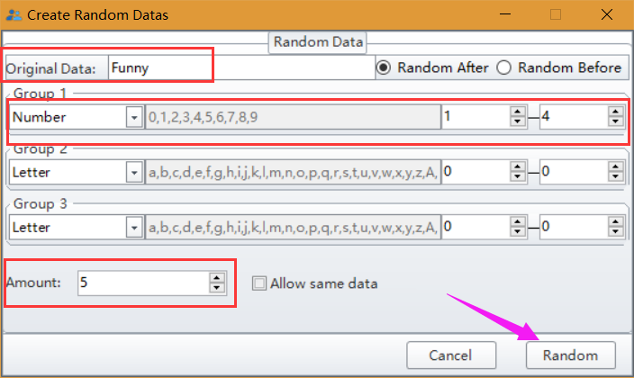
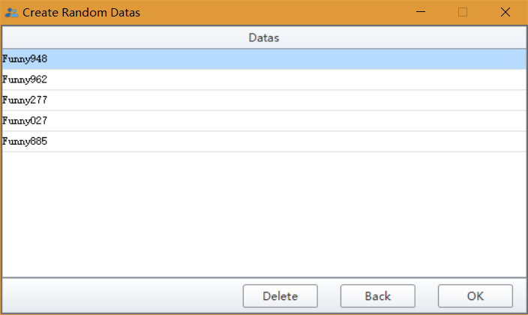
Bind Proxy/Useragent: bind proxy/useragents to these data at a time.

